# BASF CHALLENGE

## PERFORMANCE EXERCISE

Please write some automated test using a framework and programming language of your choice, to cover (at least) the following functional and non-functional requirements:

1. Correctness of the basic CRU (create, read, update) operations
2. Applications stability, even for unusual data input
3. Stable performance of at least 300 operations per seconds

## API PRE-ANALYSIS

The Challenge API consists of 3 endpoints

* General “get all objects”: GET /api/person/all
* Object creation (you get simply and id): PUT /api/person
* Object details by Id: GET /api/person/<id>

1. As the first individual requests had about 2 seconds response time, I decided an upper threshold of 10 seconds, about 5x single request response time and at the user experience limit (assuming the api consumer is triggered by an application with human interface) …
2. As the requirement say stable performance of 300 rps, I decided
   1. Stable could be achieved with less than 5% of failed requests
   2. A single run of 40 minutes splitted into 2 parts
      1. An initial period of 10 minutes in order to reach the 300 rps goal
      2. A continuous load period of 30 minutes at full 300 rps speed in order to check long periods of load

## API RESULTS

Sadly the tests have been disrupted because of api environment … I can share the “all red” report graph ….

Complete report at “target/gatling/rampUp300in10minPlus30min10secsTO/index.html”

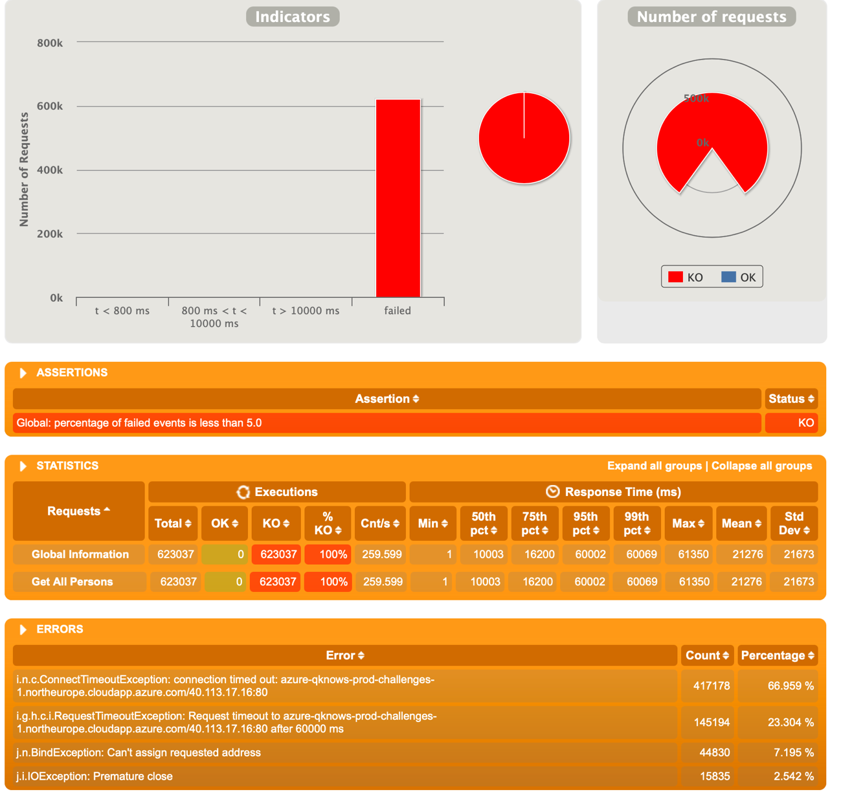

I can share also previous interactions with less users, but also +95% failed requests

